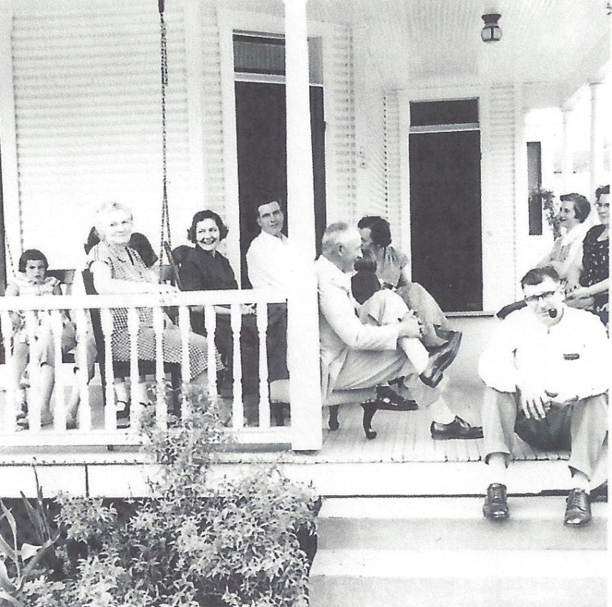

**l-r Brenda List, Josephine Worthen Wolfe, Jessie Dresbach Wolfe, Ronald List,**

**Luther List, unknown, Jo Ann List, Dorothy List, Russell Wolfe – May 1956**

|  |  |
| --- | --- |
| **C:\Users\Richard\Documents\Family Tree Maker\Book Material - Wolfe\Pics fm David List 8April2014\030-c.jpg**  **Roger E. & wife, Jessie R. Dresbach Wolfe – about 1971** | **C:\Users\Richard\Pictures\Roger & Jessie Wolfe - 1992.jpg**  **Roger E. & wife, Jessie R. Dresbach Wolfe – about 1992** |